# Neural Network Hw2 Report

1. Implement SOM perceptron

Algorithm:

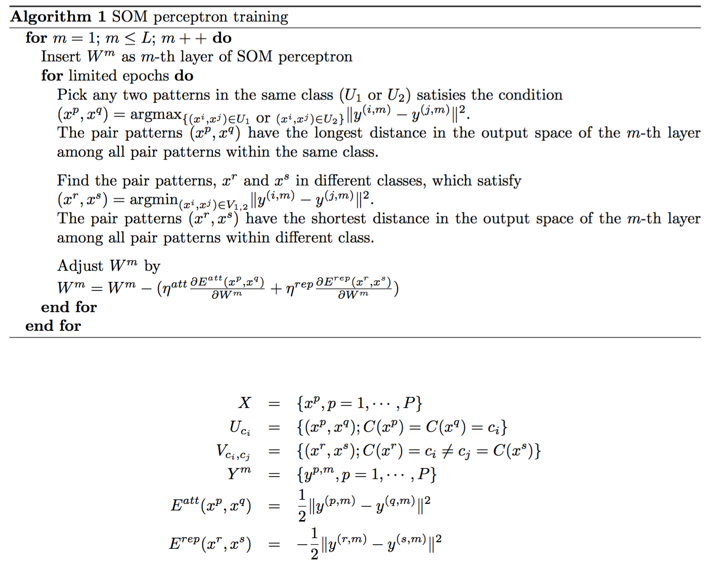

Arguments:

L = 5 (n­0=2, n1 = n2 = n3 = n4 = n1 = 5, labeling layer n6 = 1 )

Learning Rate Attraction = 0.01

Learning Rate Repelling = 10

Epochs = 5000

Activation => sigmoid function

Input Data:

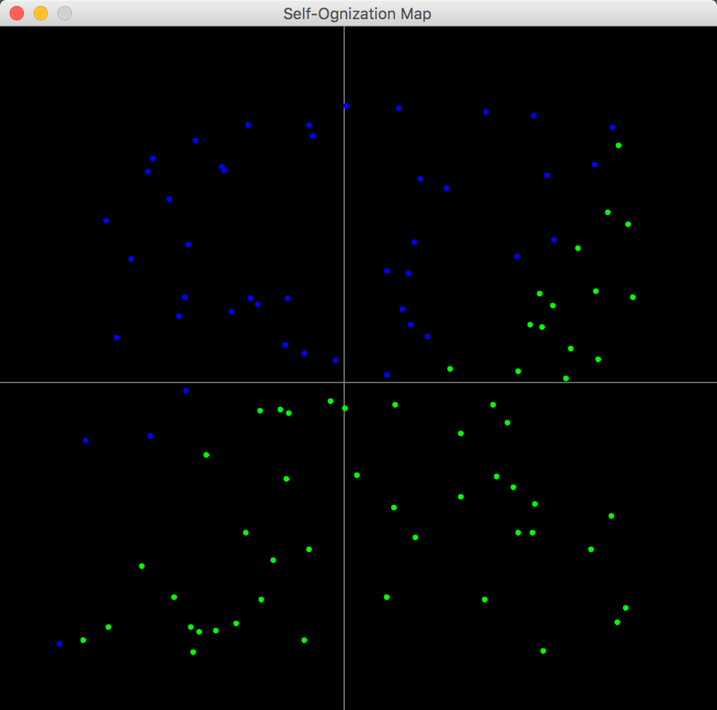

Training Result: (classification & lines in first hidden layer)

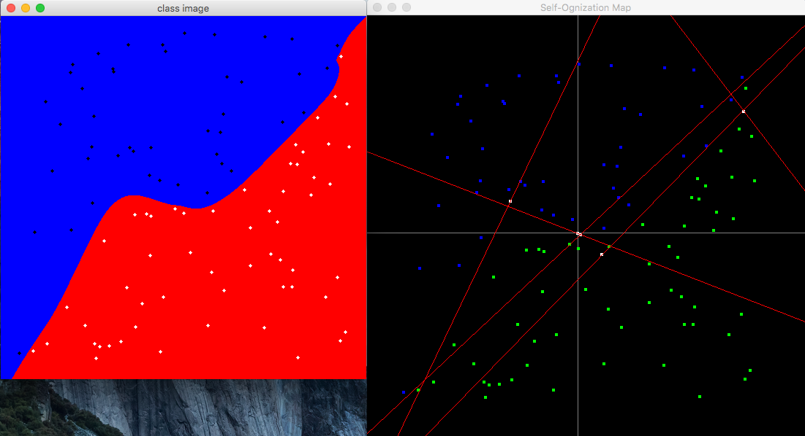

Correct Rate: 100%

Log-Longest Distance per iteration:

(iteration 1~5000 for layer 1, 5001~10000 for layer 2, etc.)

(log base e)

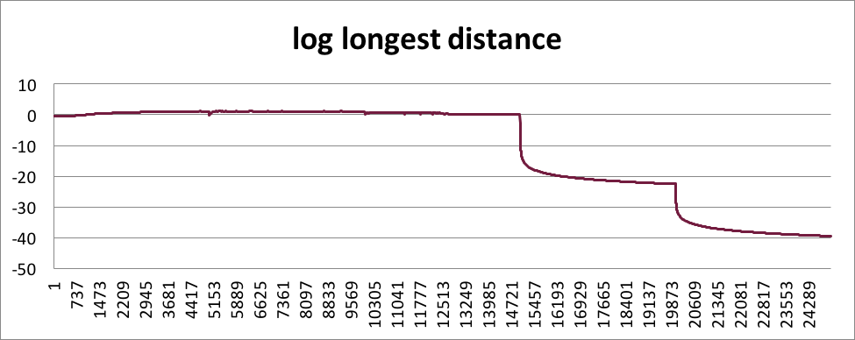

Log-Shortest Distance per iteration:

(iteration 1~5000 for layer 1, 5001~10000 for layer 2, etc.)

(log base e)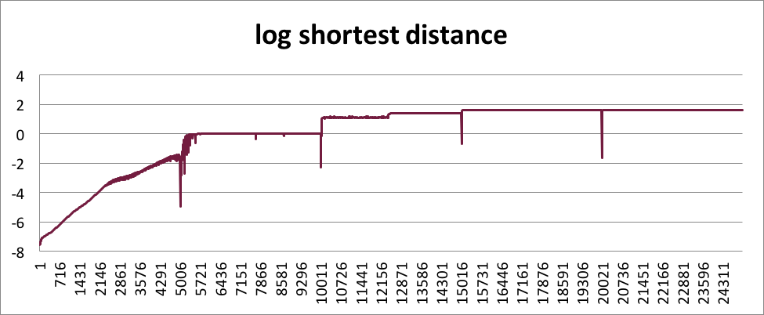

Longest Distance converge to e-39.4 ≈ 0

Shortest Distance converge to e1.61 ≈ 5 = nueral number

2. random select from same and different classes. (first 500 epochs)

Result Image: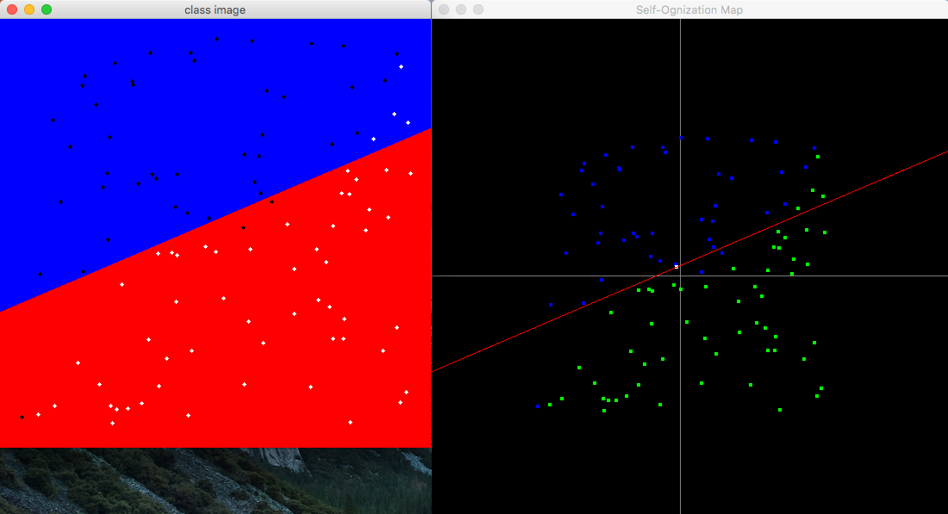

Weight: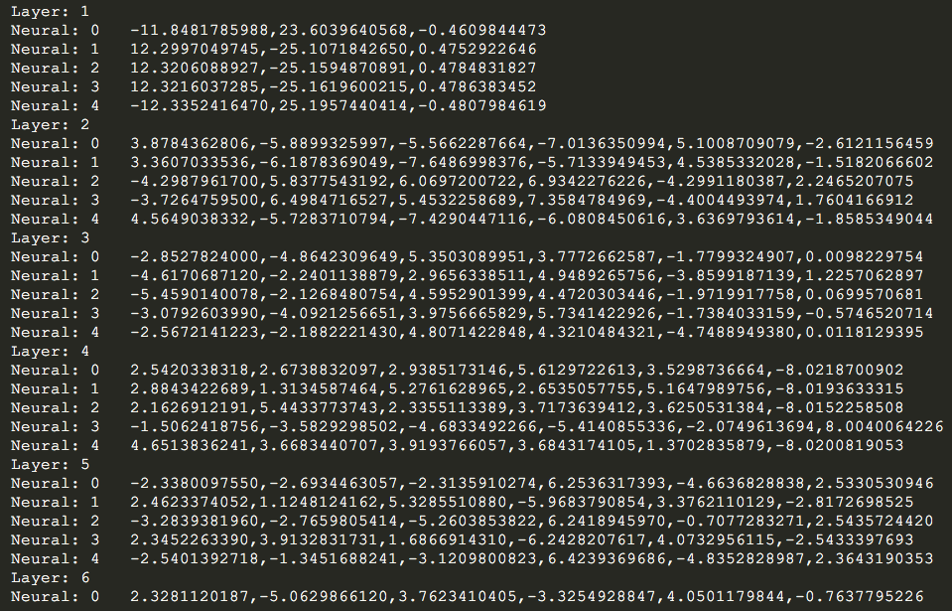

Correct Rate: 93%

Finding:

Traning faster than older SOM.

All weights of neural in the same layer may reweight to same or similar value.

Correct rate lower than older SOM.